# EXPERIMENT-2

# Install an Apache web server with PHP and MariaDB on EC2 Linux machine and host an HTML file in it.

**Ques**-1: Explain the following commands in LINUX environment:

**usermod:** This command is used to modify a user account in the Linux system. It can be used to change the user's login name, password, home directory, and other account settings.

**chmod:** This command is used to change the permissions on a file or directory in Linux. It can be used to give or take away read, write, and execute permissions for the file's owner, group, and others.

**groups**: This command is used to display the groups that a user is a member of. It can be used to check which groups a user has access to and what permissions they have within those groups.

**touch:** This command is used to create a new, empty file or update the timestamp on an existing file. It is often used to create a new file when no other data needs to be added.

**find**: This command is used to search for files and directories in the Linux file system. It can be used to search for files with specific names, permissions, or other attributes, and can also be used to execute commands on the files it finds.

**ls:** This command is used to list the files and directories in a directory. It can be used with various options, such as -l (long format), -a (shows hidden files), -h (human-readable format for file sizes), -r (list in reverse order) etc.

**vi:** This command is used to open and edit text files in Linux. It is a text editor that can be used to create, edit, and save files on the command line.

**grep:** This command is used to search for patterns in text files in Linux. It can be used to search for specific words or phrases in one or more files and display the lines that contain them.

**groupadd:** This command is used to create a new group in the Linux system. It can be used to create a new group with a specific name and GID (group ID) and assign users to that group.

**Step-1:** Connect to the linux instance you have created using rdp**.**

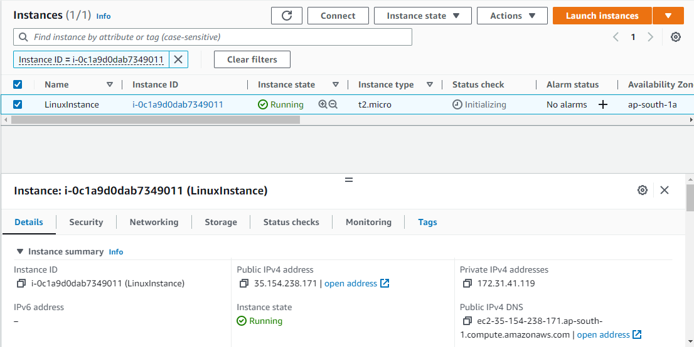

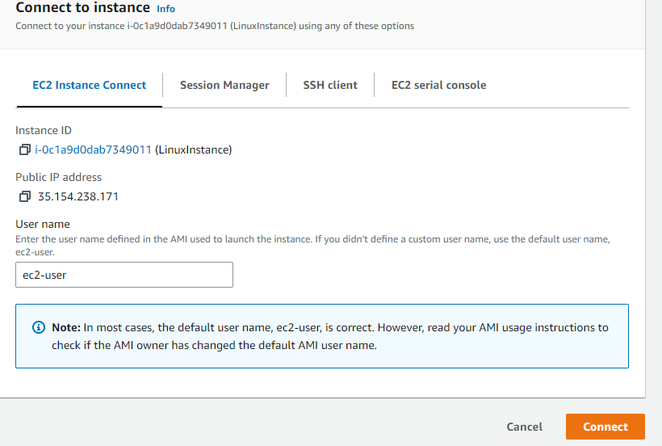

**Step-2:** We have successfully connected to the instance**.**

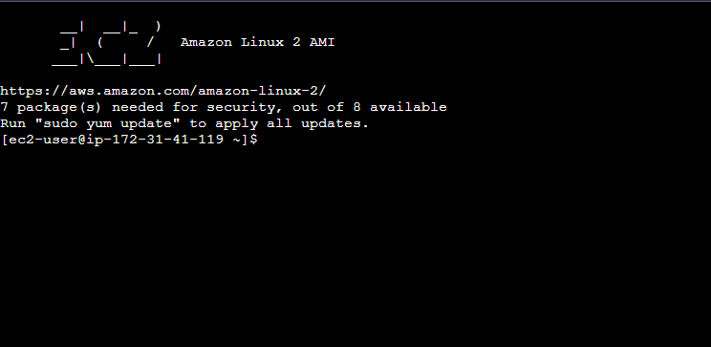

**Step-3:** Update the software using the following command

“sudo yum update -y”

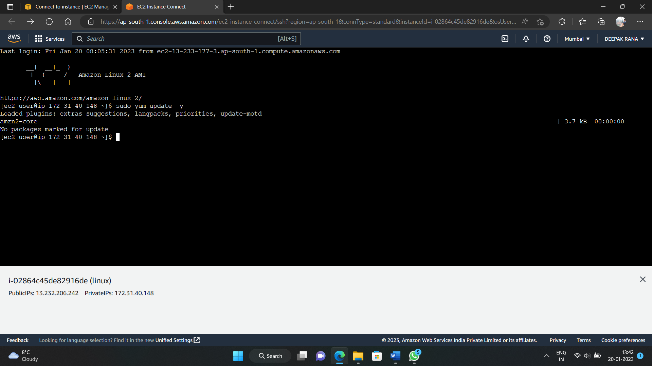

**Step-4:** After the updates complete, install the PHP software using the following command

“sudo amazon-linux-extras install php8.0 mariadb10.5”

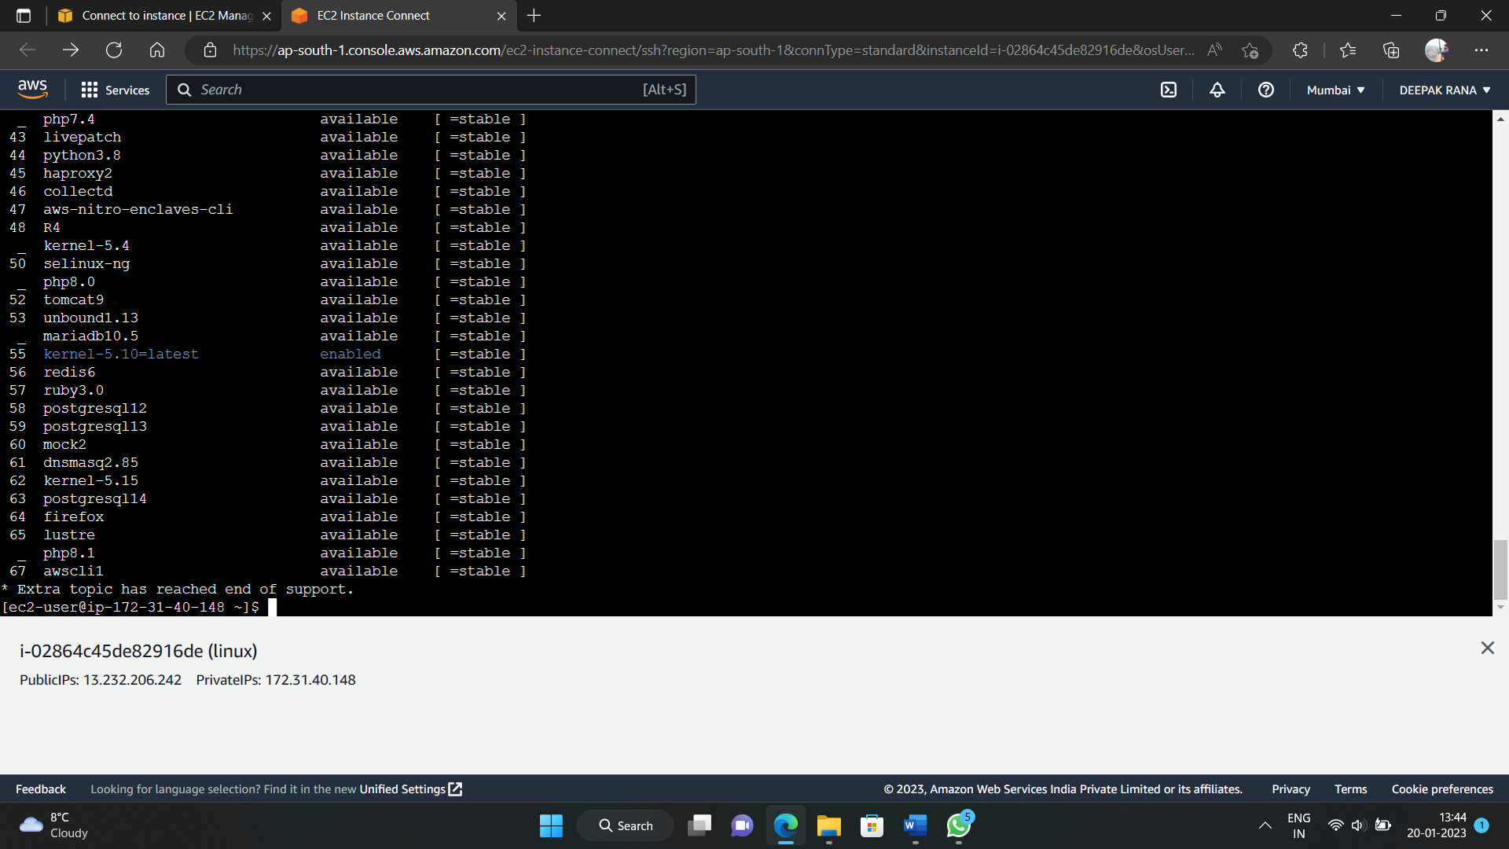

**Step-5:** You can view the version of Amazon Linux using the following command

“cat /etc/system-release”



**Step-6:** Now install the Apache web server using the following command

“sudo yum install -y httpd”

**Step-7:** Start the web server with the following command

“sudo systemctl start httpd”

**Step-8:** Now check where the server is enabled or not

“sudo systemctl is-enabled httpd”



**Step-9:** Now create a group www using the following command

“sudo groupadd www”

**Step-10:** Now add the ec2-user user to the apache group.

“sudo usermod -a -G apache ec2-user”

**Step-11:** Now log out to refresh your permissions and include the new apache group..

“exit”

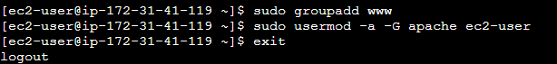

**Step-12:** Log back in again and verify that the apache group exists with the groups command..

“groups”



**Step-13:** Now change the group ownership of the /var/www directory and its contents to the apache group.

“sudo chown -R ec2-user:apache /var/www”

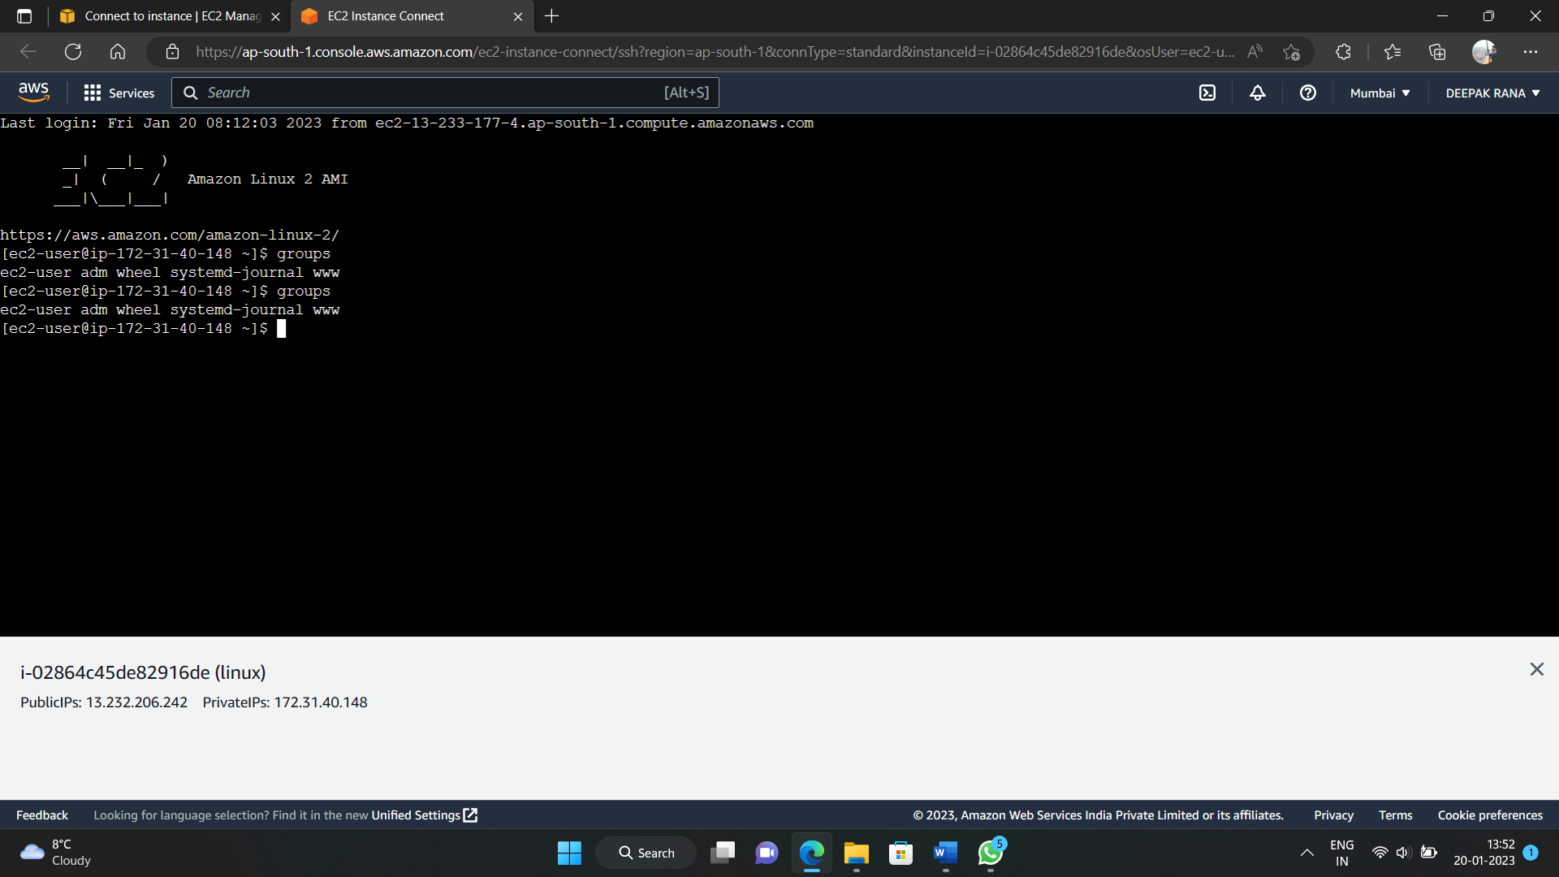

**Step-14:** Change the directory permissions of /var/www and its subdirectories to add group write permissions and set the group ID on subdirectories created in the future.

“sudo chmod 2775 /var/www

find /var/www -type d -exec sudo chmod 2775 {} \;”

**Step-15:** Change the directory to /var/www/html.

“touch /var/www/html/index.html”

“vi /var/www/html/index.html”

**Step-16:** Now open the public ip address of the instance in browser.

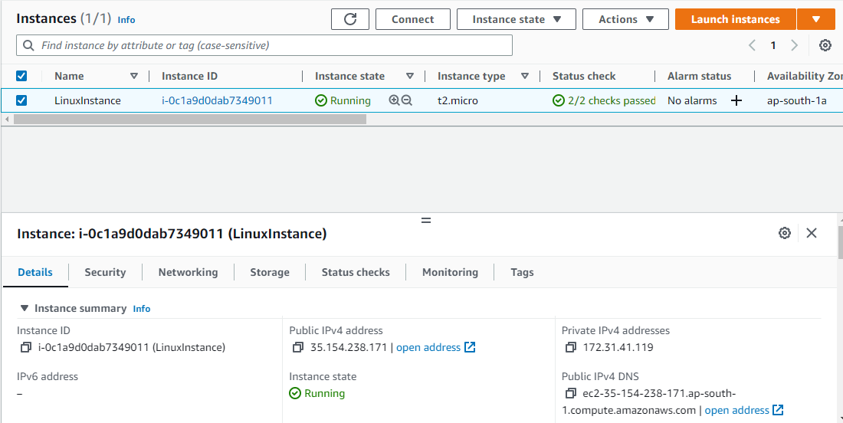

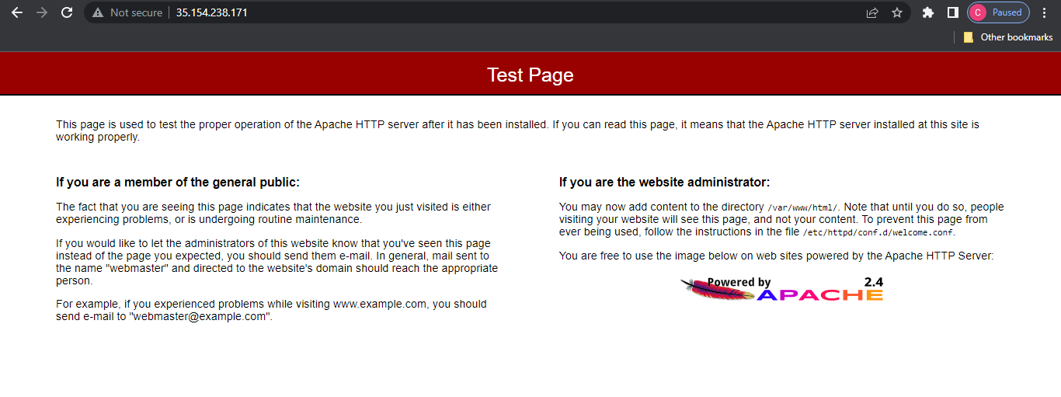

**Step-16:**Now open vim editor and type the html code you want to display and save and exit from the same using “:wq”

index.html

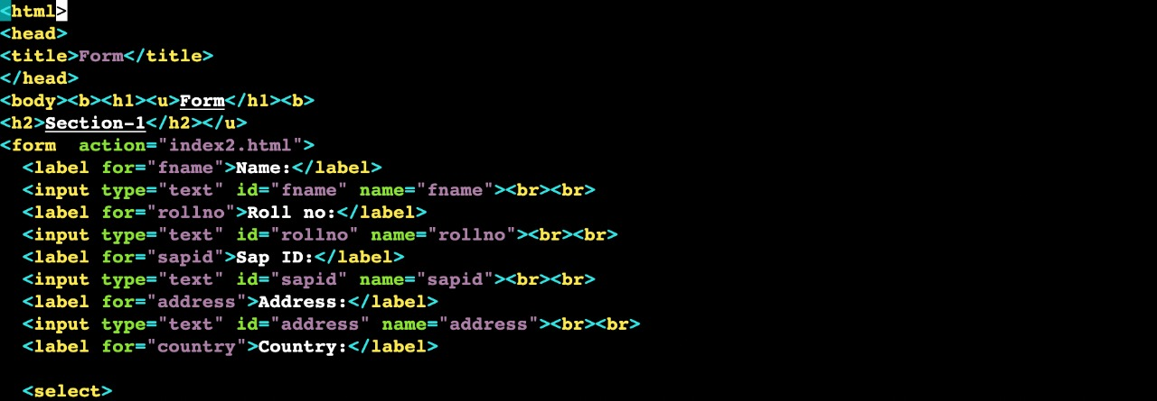

index2.html

